

American International University- Bangladesh

CSC 3222: Web Technologies

CO1.1 and CO2.1 Evaluation

Project Report

Spring 2021-22

Project Title : Online Shopping Management

Section : E

|  |  |
| --- | --- |
| Student Name | Student Id |
| Md. Tamim Rahman Fatmi | 17-35691-3 |
| Md. Rukonuzzaman | 17-34371-1 |
| Tuhin Tanjemul Hoque | 19-41020-2 |
|  |  |

**Introduction:**

*This Website is about online based shopping management where people mostly who can use internet will be able to buy goods which are advertised or listed in the website’s page. This website will help people to shop easily from anywhere. It will decrease the hassle of shopping for elder persons, physically disabled persons and working women in Bangladesh.*

**Background Study**

*We are trying to build an online based system in which general people will be able to order different kinds of goods through online. There will be three kinds of users including the Customers. There will also be an Admin who will have full control over the profiles of delivery guys and customers. The Delivery Guys could be those people who will be willing to create profile on this site or system. The Admin will be able to confirm the address and the order before sending a Delivery Guy. The Admin will also be able to cancel any order or block any profile he/she likes. The Customers and the delivery guys will have to provide valid documents in order to create profiles. The Customers can complete the payment thorough any way he/she likes.*

*We mostly came about the idea depending on the lock down situation during the COVID-19 pandemic. Some other similar website like, “daraz.com, foodpanda.com and chaldal.com” really helped to get the concept of E-commerce.*

*In order to get our website in shape, “Google and W3 School” really helped us. Moreover, our honorable faculty member, “Nazmus Sakib Shan” played a very important role by teaching us important topics which helped us to build the website.*

**Requirement Analysis:**

1. User Category:

There are 3-types of Users here. They are:

* Admin
* Customers
* Delivery Guys

1. Feature List:

In this project the “Customers” has the following features:

* Place Order
* Order Cancel
* Change Password
* Log-in
* Log-out
* View Profile
* Edit Profile
* Payment Method

In this project the “Delivery Guys” has the following features:

* Accept Order
* Order Cancel
* Change Password
* Log-in
* Log-out
* View Profile
* Edit Profile

In this project the “Admin” has the following features:

* Order List Maintenance
* Order Cancel
* Change Password
* Log-in
* Log-out
* Complete Control Over Both Users Accounts
* View Profile.
* Add or remove products

**Design:**

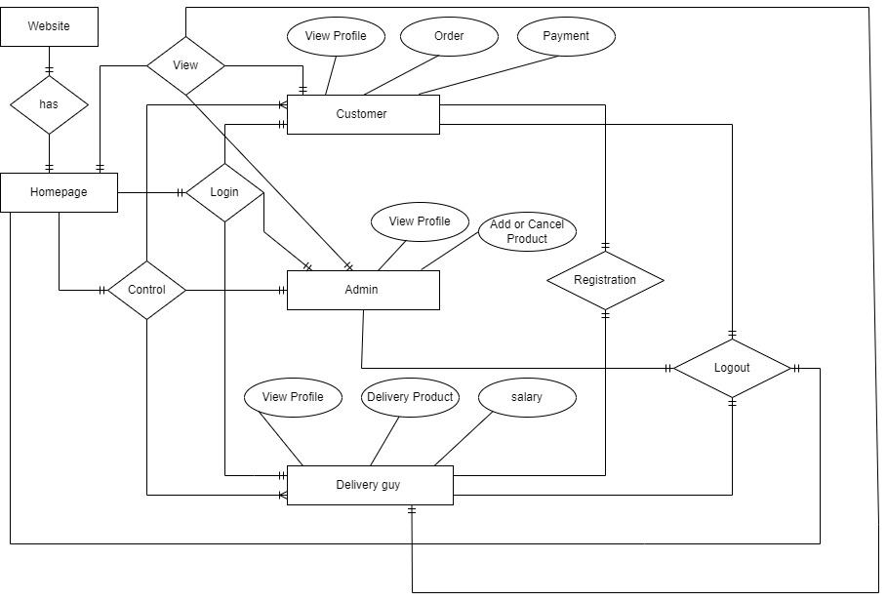

**Tools Used:**

To develop this project, we have used the following:

* HTML
* PHP
* CSS
* Bootstrap
* My SQL

**System Images against the Specification:**

**1.**

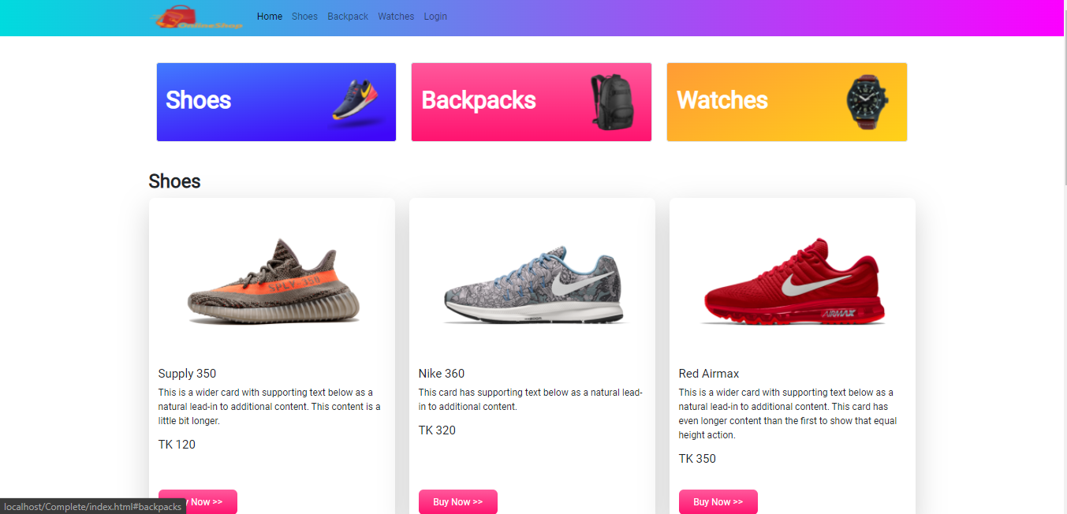

**2.**

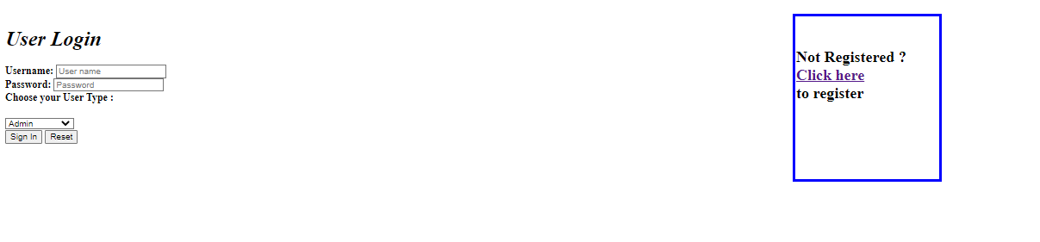

**3.**

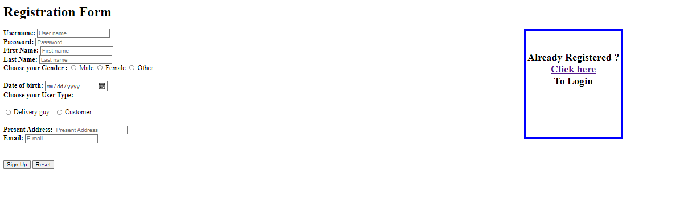

**4.**

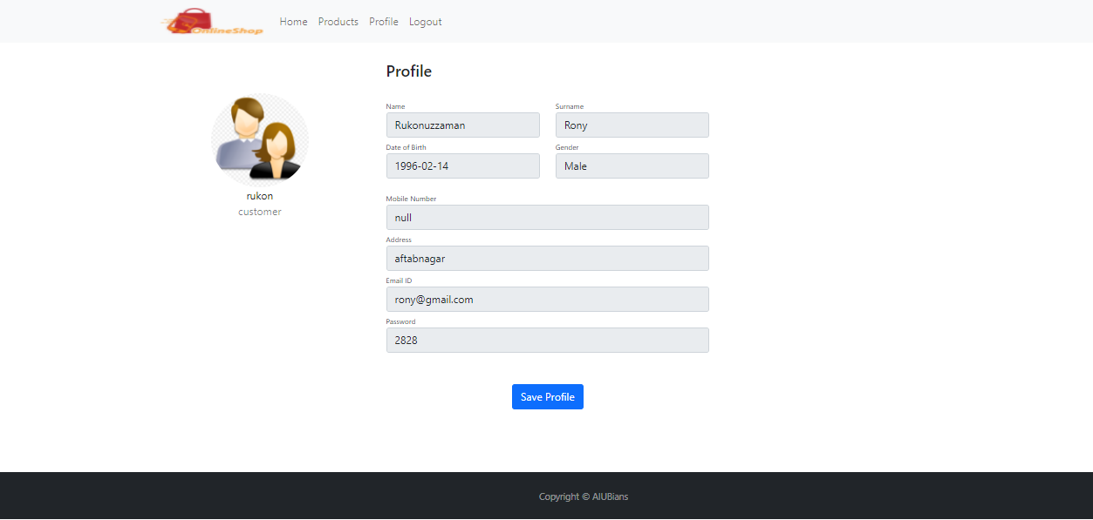

**Impact of this Project:**

*We are trying to build an online based system in which general people will be able to order different kinds of goods through online. There will be three kinds of users including the Customers. There will also be an Admin who will have full control over the profiles of delivery guys and customers. The Delivery Guys could be those people who will be willing to create profile on this site or system. The Admin will be able to confirm the address and the order before sending a Delivery Guy. The Admin will also be able to cancel any order or block any profile he/she likes. The Customers and the delivery guys will have to provide valid documents in order to create profiles. The Customers can complete the payment thorough any way he/she likes.*

*In this modern world, time has become the biggest entity to spare. That is why working people will be able to minimize their specious time of shopping by using our website. Again, those people who are unable to go in the market for shopping will be greatly benefited by using the home delivery service.*

*In some specific situation like COVID-19, people will be also able to stay safe and secure as much as possible because of using our online shopping system. Products will be delivered at their door step without any kinds of hassle. Customer will always get the top most priority from our website.*

*At present, our website does not have any kinds of tracking system yet. But surely, we will include such services in our website in the near future. Others important system which will be included as Customers’ demand.*

|  |  |  |  |  |  |
| --- | --- | --- | --- | --- | --- |
| CO1.1 and CO2.1 Evaluation: Project Report Evaluation | | | | | |
| Project Proposal  (5) | Background  Study  (5) | Requirement Analysis  (5) | Entity  Diagram  (5) | System Images  against the  Specification (5) | Total (25) |
|  |  |  |  |  |  |
|  | | | | | |